***7. The Concept of Scope in the Context of Javascript***



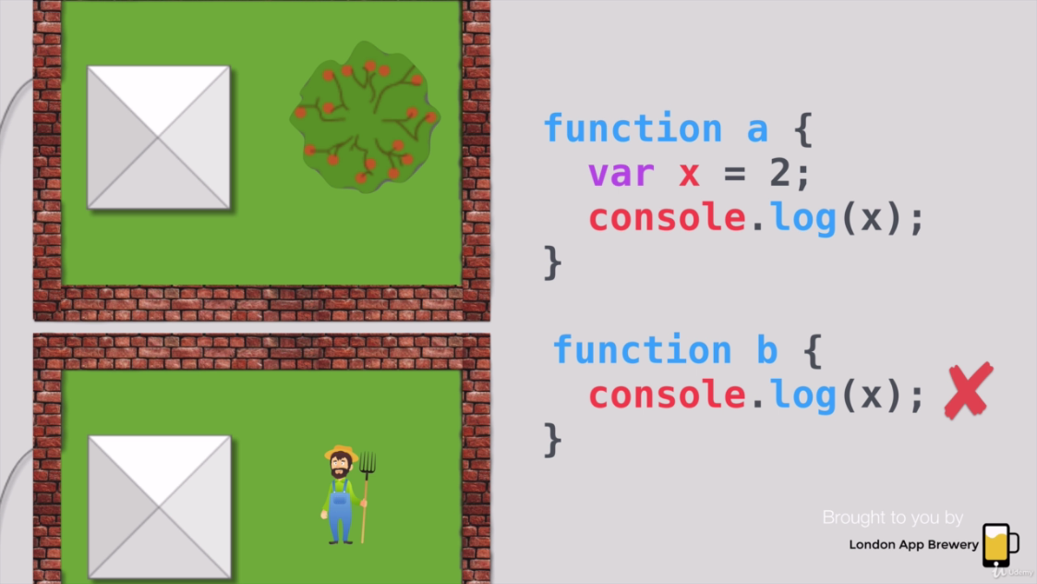

* Block scope //Local scope
* Function scope
* Global scope

<https://www.w3schools.com/js/js_scope.asp>



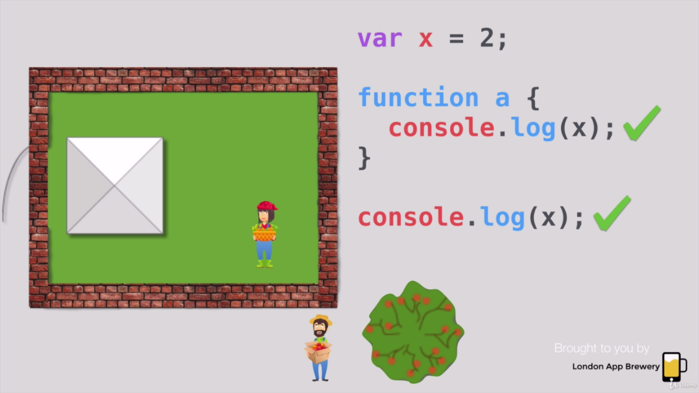

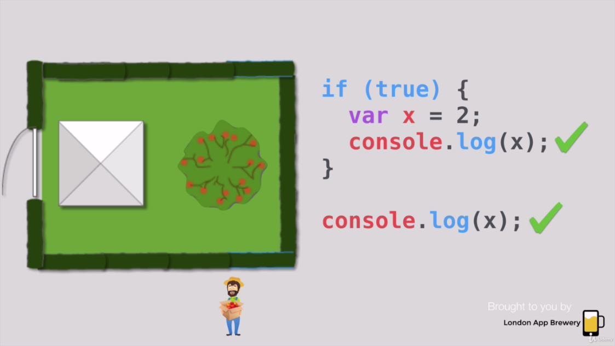

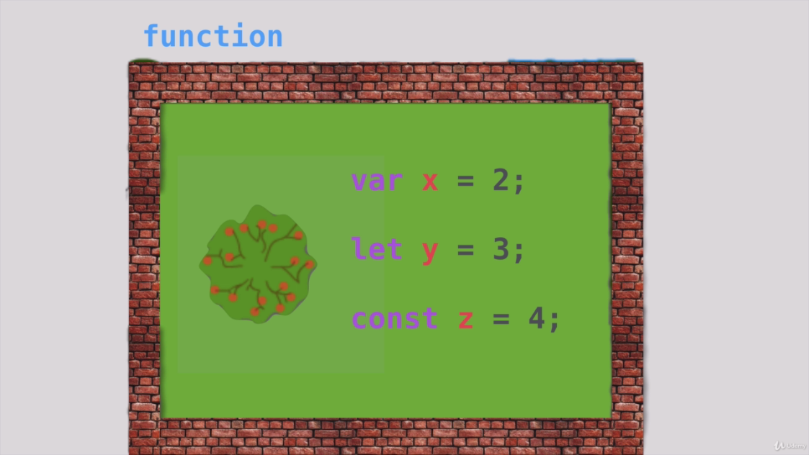

**Note:**

Const cannot be changed

Var and let can be change but slightly different in scope

let in javascript <https://www.w3schools.com/js/js_let.asp>

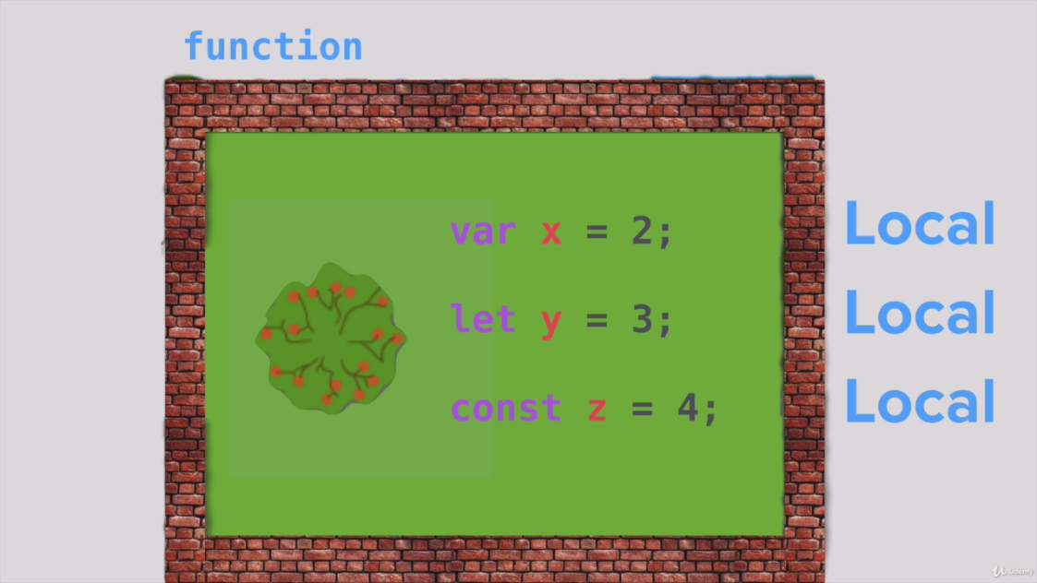

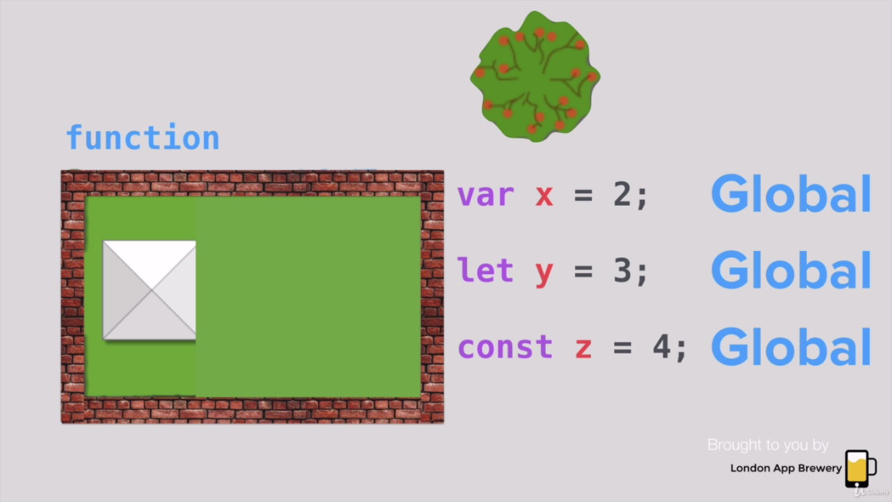

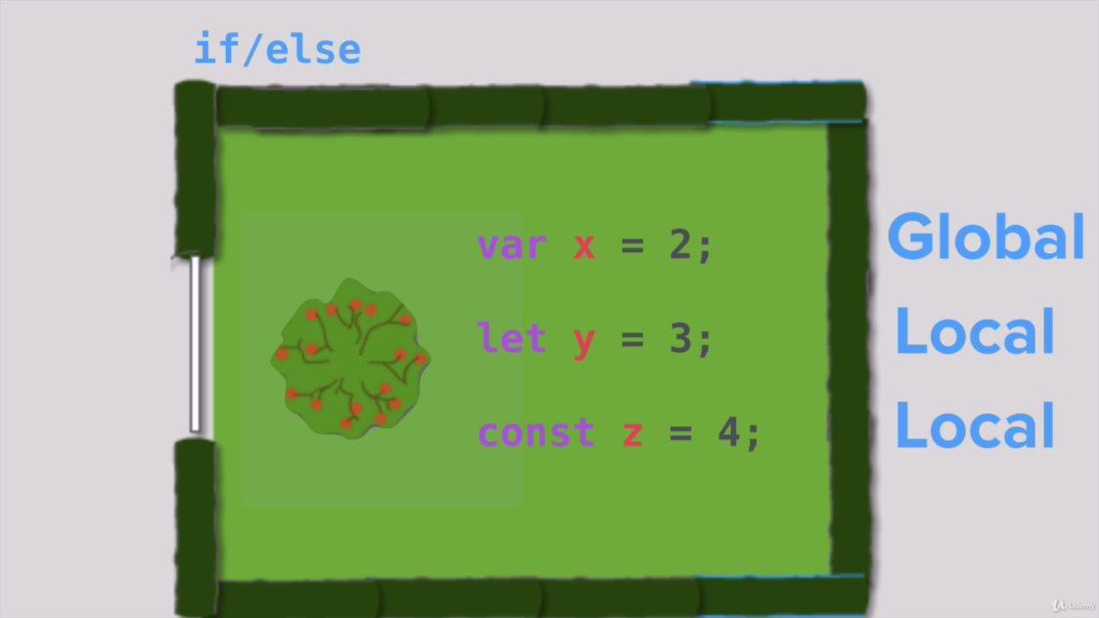

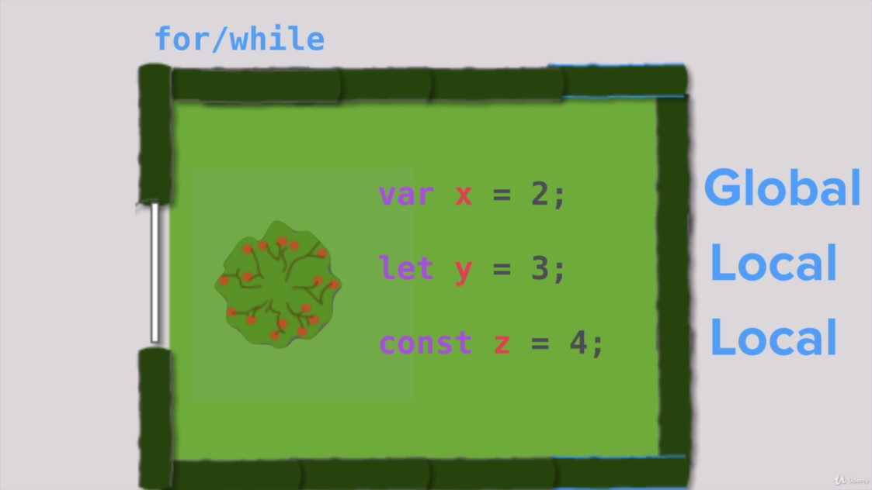

***Code:***

Everything is same but only different is that in app.js scope is changed from var to let.

**Index.html:**

<!DOCTYPE html>

<html lang="en" dir="ltr">

<head>

<meta charset="utf-8">

<title>To Do List</title>

</head>

<body>

<h1>It's a weekday!</h1>

<p>Why are you not working.</p>

</body>

</html>

**App.js:**

//jshint esversion : 6

const express = require("express");

const bodyParser = require("body-parser");

const app = express();

let items = ["Buy Food", "Cook Food","Eat Food"];

app.set('view engine', 'ejs');

app.use(bodyParser.urlencoded({

extended: true

}));

app.get("/", function(req, res) {

let today = new Date();

let options = {

weekday: "long",

day: "numeric",

month: "long"

//year:"numeric"

};

//var day=today.toLocaleDateString("en-US"); //8/24/2022

let day = today.toLocaleDateString("en-US", options); //add date format in us english format

//Wednesday, August 24, 2022

res.render("list", {

kindOfDay: day, //replace the entire value of kind of day with current day

//newListItem: item //Its written to fix below problem of server

newListItems :items

});

});

app.post("/", function(req, res) {

var item = req.body.newItem;

//console.log(item);

//res.render("list",{newListItem:item});

items.push(item);

res.redirect("/"); //simple form of abov line

});

app.listen(3000, function() {

console.log("Server started on port 3000.");

});

**List.ejs:**

<!DOCTYPE html>

<html lang="en" dir="ltr">

<head>

<meta charset="utf-8">

<title>To Do List</title>

</head>

<body>

<h1><%= kindOfDay %></h1>

<ul>

<!--

<li>Buy Food</li>

<li>Cook Food</li>

<li>Eat Food</li>

-->

<% for(var i=0; i<newListItems.length;i++){ %>

<li><%= newListItems[i] %></li>

<% } %>

</ul>

<form class="" action="/" method="post">

<input type="text" name="newItem">

<button type="submit" name="button">Add</button>

</form>

</body>

</html>